SQL server crashes and critical failures

Software crashes. **WE** can’t stop that. What **WE** can do is prepare ourselves through education and practice to be able to **act quickly** and resolve these critical issues.

In the early days of **SQL Server** many support calls were server down issues that ended up being bugs in SQL Server. While this still happens, today many of those calls aren’t the fault of SQL Server.

For example. On Microsoft’s case history of database corruption **99%** of **ALL**database corruption can be traced back to the IO subsystem.

Either way, when **SQL Server crashes** it can be a traumatic experience for a DBA. If a production box crashes during core hours **WE** need to know what steps to take to resolve the problem as quickly and as cleanly as possible.

This course will take **US** beyond where to look. **WE** will cover **RECOVERY INTERNALS**and the fundamentals of how to analyze, diagnose and resolve critical errors.

**WE** will cover the SQL Server Error Logs**in great detail**. One of the first places as SQL Server DBAs **WE** look to diagnose critical failures is the SQL Server Error logs.

**WE** will cover server startup failures and **analyze SQL Server stack dumps**. Additionally, we will analyze several commonly occurring exception signatures.

**WE** will create a troubleshooting task list as use it as a template for**resolving these crashes** and critical errors.

Tools we need to start the course

**1.command prompt as Administrator**

**2. SQL server Manager**

**3. Computer management**

**Three categories of critical Failure**

1. **Stack dumps**
2. **Crashes**
3. **Other Critical Errors**

**Startup Parameters SQL Server needs :**

1. **Starting a named Instance :**

**C:\Users\Administrator>net start mssql$sql2k8**

1. **When we want use SQL server in single user node :**

**C:\Users\Administrator>net start mssql$sql2k8 \n**

**Troubleshooting the failed startup with account locked out :**

1. **Open computer management**
2. **There is a chance of pass word expire.**
3. **Double click on user, uncheck password never expires.**

**Troubleshooting the failed startup when port is already in use:**

1. **To get the list of ports used by sql server Instances:**

**Netstat –o**

1. **go to sql server configuration ->to change the port.**

**Clean Error log of SQL server**

* **Stop the instance of SQL server from SQl server configuration manager**
* **Delete the error logs**
* **Again start the instance of SQL server**
* **Again the the error log will be created as the instance is started but will be from 0.**

**What is error log?**

**Restoring the resource DB from other Instances:**

1. **Stop instance of express edition**
2. **Go to location of resource db**
3. **Delete the resource db**
4. **Copy the resource db from standared edition to express edition**
5. **Again start the instance of express edition.**

**Restoring Master database when instance is online**

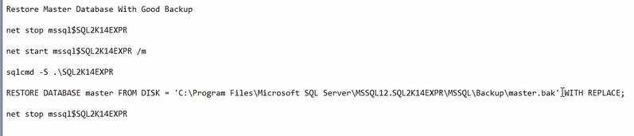

**Restore corrupt model DB from other instances**

1. **Stop instance of express edition as well as standandard edition**
2. **Go to location of model db in express edition**
3. **Delete the model db**
4. **Copy the model db from standared edition to express edition**
5. **Again start the instance of express and standard edition.**

**Recovering the lost SA password**

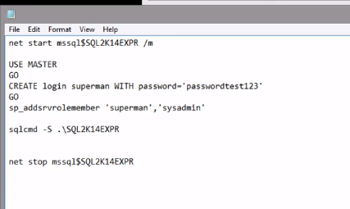

**Repairing tempDB corruption :**

**Stop the instance ,Delete the tempdb , start the instance- it will recreate the temp db**

**Summary :**

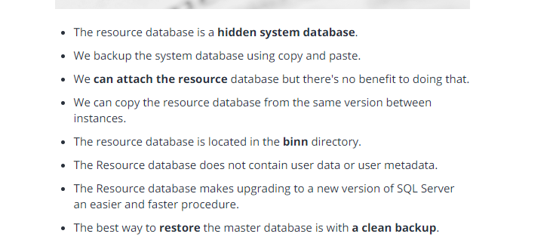

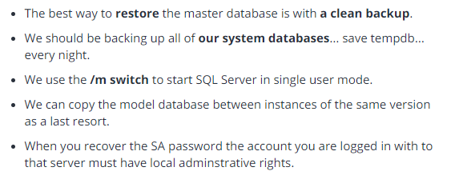

**Refrence link:**

<https://www.udemy.com/cart/subscribe/course/561920/>